**GENERAL HUMAN BIOLOGY**

**TASK 9 - RAT DISSECTION PRACTICAL MARKING KEY**

This assessment has two parts –

* Information from video **(7 marks)**
* Rat dissection and questions **(18 marks)**

**PART ONE**

Answer the following questions based on the videos your teacher shows you.

1. Why do pregnant female rats have 5 pairs of nipples, according to the video? (1 mark)

* Because they give birth to lots of babies / multiple pregnancies

1. In the video the teacher separates the muscle from the skin using the blunt side of the scissors. What is the importance of this? (1 mark)

* So you don’t cut the muscle / Prevents damage to the skin /separate the connective tissue

1. As you cut the muscle, you lift it up. Why? (1 mark)

* Prevents damage to the organs underneath

1. The uterus is Y-shaped in the female rat. How is this different to the uterus of a female human?

(1 mark)

* Human is one round shape / is all together / not split into two sections

1. Do female rats usually have a pregnancy with a single offspring or multiple offspring? (1 mark)

* Multiple offspring

1. What is the benefit of the Y-shaped uterus for a female rat? (2 marks)

* Is able to carry more than one offspring at a time
* Spread them around / easier on mother’s body

**Part Two**

Read your Rat Dissection Protocol CAREFULLY! This will help ensure that you follow it methodically and do not make a mistake.

* Time management (1)
* Group Work (1)
* Methodical / follow instructions (1)
* No help required / dissection looks well done (1)

1. In the space provided, draw a diagram of your rat’s reproductive system.
   * Male or Female Correct and structures as evidence (1)
   * Used pencil (1)
   * Scientific drawing /outlines of structures / no shading (1)
2. List any differences that you can see between your rat and the human reproductive system.

*Any correct comparison for 1 mark. Example:*

* Male rats have the same organs as humans. The differences are in the relative sizes.
* Female rat has two uteri, humans only one; uteri are very elongated, humans relatively short; there are five to seven pairs of mammary glands, humans have one pair; the rat’s uterine tubes are very short compared with a human’s

Below are diagrams of a dissected male and dissected female rat. Label the reproductive structures for each rate below. (4 marks)

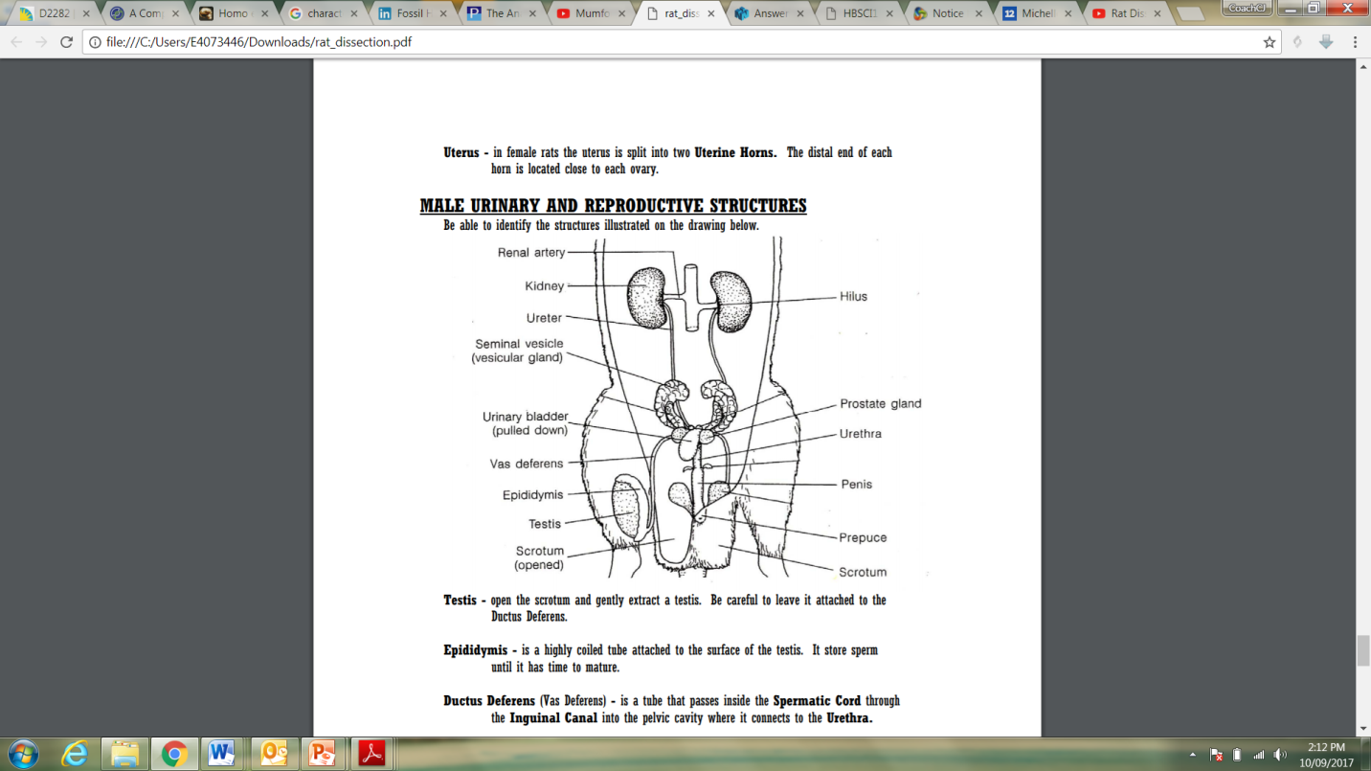

STRUCTURES

Seminal vesicle, Penis, Testes, Scrotum, Prostate gland, Vas deferens. Epididymis, Urethra

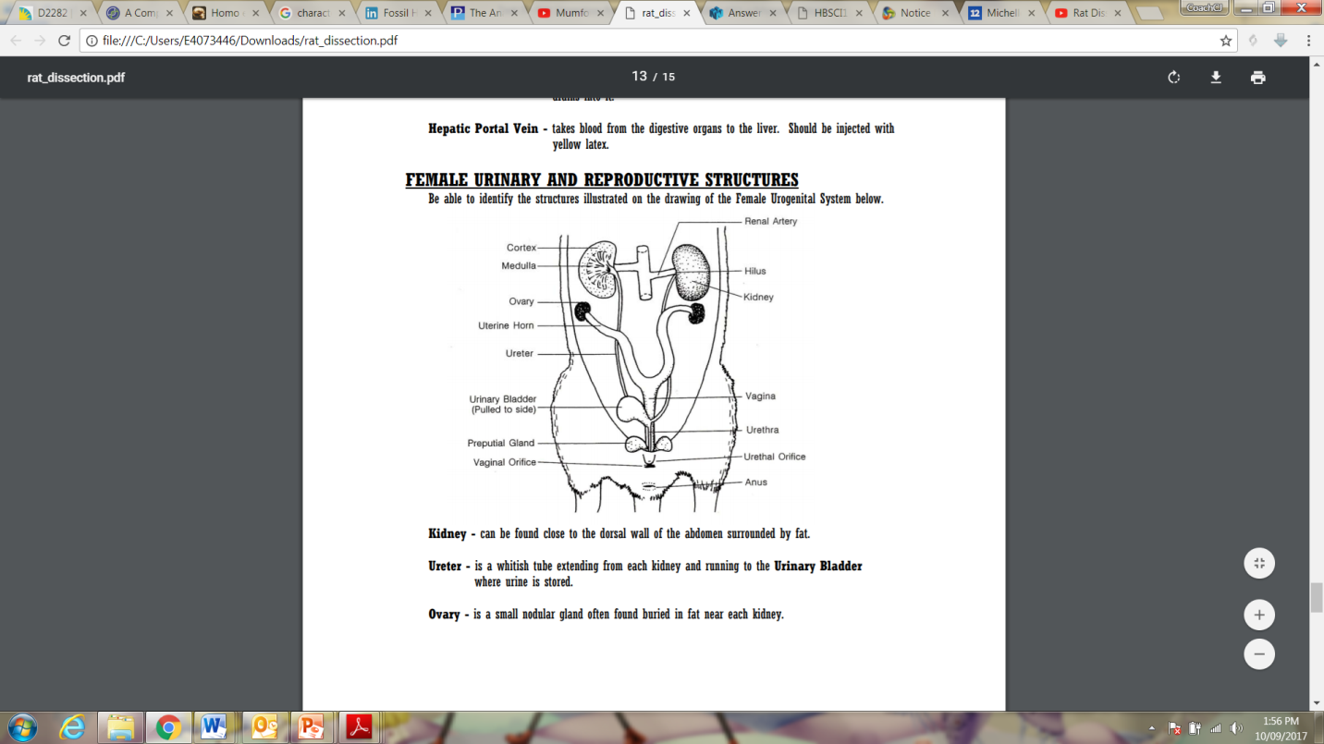

STRUCTURES

Vaginal opening, Ovary, Anus, Uterine horns, Vagina

* If all structures correct from given names (4)
* If 9-12 correct (3)
* 5-8 correct (2)
* 1-4 correct (1)

Below is a diagram showing the development and pathway taken by a zygote after fertilisation has occurred.

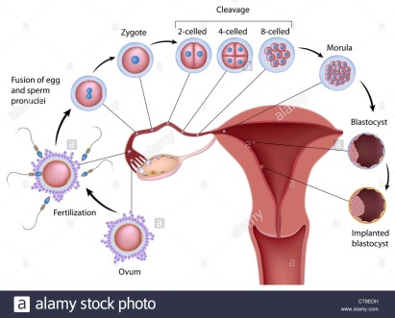

1. What form of cell division does the zygote go through to increase its number of cells and grow?

(1 mark)

* Mitosis

1. As a zygote (fertilised egg) continues to develop and mature during pregnancy, the name given to it changes. What are two other names used during pregnancy for the developing unborn child? (2 marks)

*Any 2 of the following for 1 mark each:*

* Blastocyst
* Morula
* Foetus
* Embryo

1. An ectopic pregnancy is where the fertilised egg does not implant itself into the uterine wall. This results in the pregnancy being terminated either naturally (due to incorrect growing conditions) or by medical intervention. Why would an ectopic pregnancy not allow for the growth and development of a fertilised egg? (3 marks)

*Any 3 points for 1 mark each. Examples:*

* Needs to be in uterus to implant to gain nutrients
* No blood vessels to get oxygen and nutrients and exchange waste with
* Elsewhere would be too small for growth
* Would implant into lining that is too thin
* Will not take /survive
* Can cause extreme pain for mother and it would be terminated as life threatening